张锐博士学术报告

报告题目：Secure outsourced location-based skyline query processing over untrusted cloud
报 告 人：张锐博士（美国特拉华大学）
报告地点：电信学院会议室（南一楼中302）
报告时间：12月19日上午10: 00
邀 请 人：蒋洪波教授

报告内容简介
The rapid advance in cloud computing has made it increasingly popular for location-based service providers (LBSPs) like Yelp to outsource their points of interest (POI) datasets to third-party cloud service providers (CSPs), which in turn answer various data queries from mobile users on their behalf. A primary security concern in such a system is that the CSPs cannot be fully trusted, which may return forged and/or incorrect query results in favor of the POIs willing to pay. As an important type of queries, location-based skyline queries (LBSQ) ask for the POIs that are not spatially dominated by any other POI with respect to certain query location. In this talk, I will first introduce several schemes that allow the users to verify both the authenticity and soundness of any LBSQ result returned by an untrusted CSP under the Euclidean distance metric by exploring a unique neighboring relationship among POIs. I will then briefly discuss how to extend the schemes to support secure outsourced LBSQ processing under the shortest path distance metric.

报告人简介
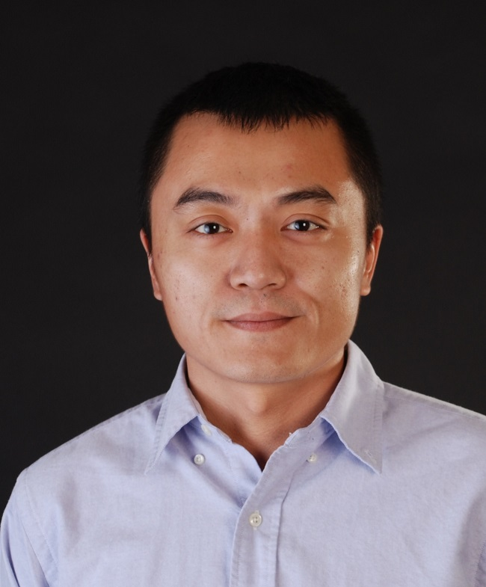

Rui Zhang is an Assistant Professor in the Department of Computer and Information Sciences at the University of Delaware (UD). He received the Ph.D. degree in Electrical Engineering from Arizona State University in 2013, the M.E. degree in Communication and Information Systems from Huazhong University of Science and Technology in 2005, and the B.E. degree in Communication Engineering from Huazhong University of Science and Technology in 2001. Before joining the UD, he was an Assistant Professor in the Department of Electrical Engineering at the University of Hawaii from 2013 to 2016. His research interests are the security and privacy issues in wireless networks, mobile crowdsourcing, mobile systems for disabled people, cloud computing, and social networks. He is an Associate Editor of IEEE Internet of Things Journal. He was a general co-chair for Information Security Conference 2016, a local-arrangement co-chair for ACM MobiCom 2014, and has been a TPC member for various conferences such as IEEE INFOCOM, IEEE ICDE, IEEE CNS, IEEE SECON, and ACM ASIACCS.

